**Submission 2: Prototyping**

***Cat Tanks! Paper Prototype***

*Dominique Sosseh,*

*Alex Linham,*

*Andreea Stoica,*

*Vladimar Kebeng,*

*Miruna Milu,*

*Gabriel Cruceanu*

**Level 01, Prototype tutorial.**

Below is an example level. The map starts zoomed out, allowing the player to see both the cat tank (left) and the enemies position (right). The screen then focuses on the cat tank.

We focused on obeying MOSCOW rules for this assignment. That is, Must have, Should have, Could have, Wish list, with Must have being the most important objectives on the to-do list. We realised that some things, like the shot power button described in the GGD, were not necessary, so we removed them to save production time.

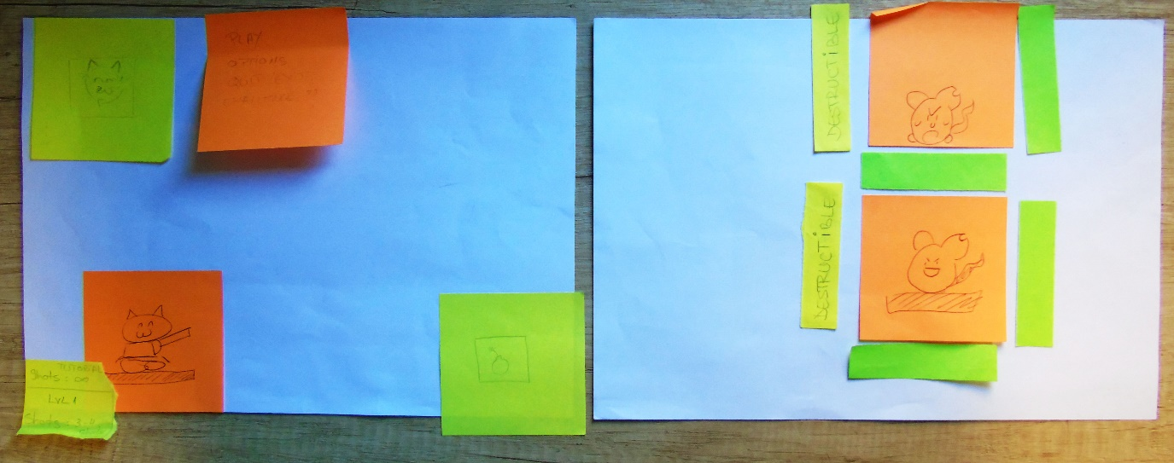 We also discussed and drew designs for the buttons and User Interface (UI). We used scraps of paper, post it notes, and placeholder art to represent each essential element.

Below is the Cat Tank area. The player can see a Cat Tank, a firing button, a Cat swap button and an options button (1, 2, 3, 4 respectively). The cat tank is stationary, but if the player moves their finger on screen, the gun barrel represented by a blue paper clip (5) will follow that change in position. The red paperclip (6) represents the fired projectile, which obeys gravity (unless the selected cat tank is Mecha cat, as he fires lasers). In the bottom left is the level name, and the amount of shots for the level.

The options button is displayed with the words “play, options, quit/exit, challenge??” written on it. The options should be a cog wheel, as this is often a universal symbol for options. Selecting this settings button will open a Heads-Up Display (HUD) with the previously listed options as functional buttons. The challenge mode is a proposed level with tonnes of mice and destructible planks, and the challenge is to score as highly as possible by killing as many mice with a limited number of shots. This challenge level is not necessary to create, but would be a fun addition, so we noted it down so as not to forget.

The cat swap button is a recycling symbol mixed with a cats’ face. Selecting this button will open a screen with a selection of cat tanks to choose from and a back to level button. The fire button (2) will launch the projectile (6) at the angle of the gun barrel (5). We discussed more about the layout of this screen in a later session, and decided that the buttons for 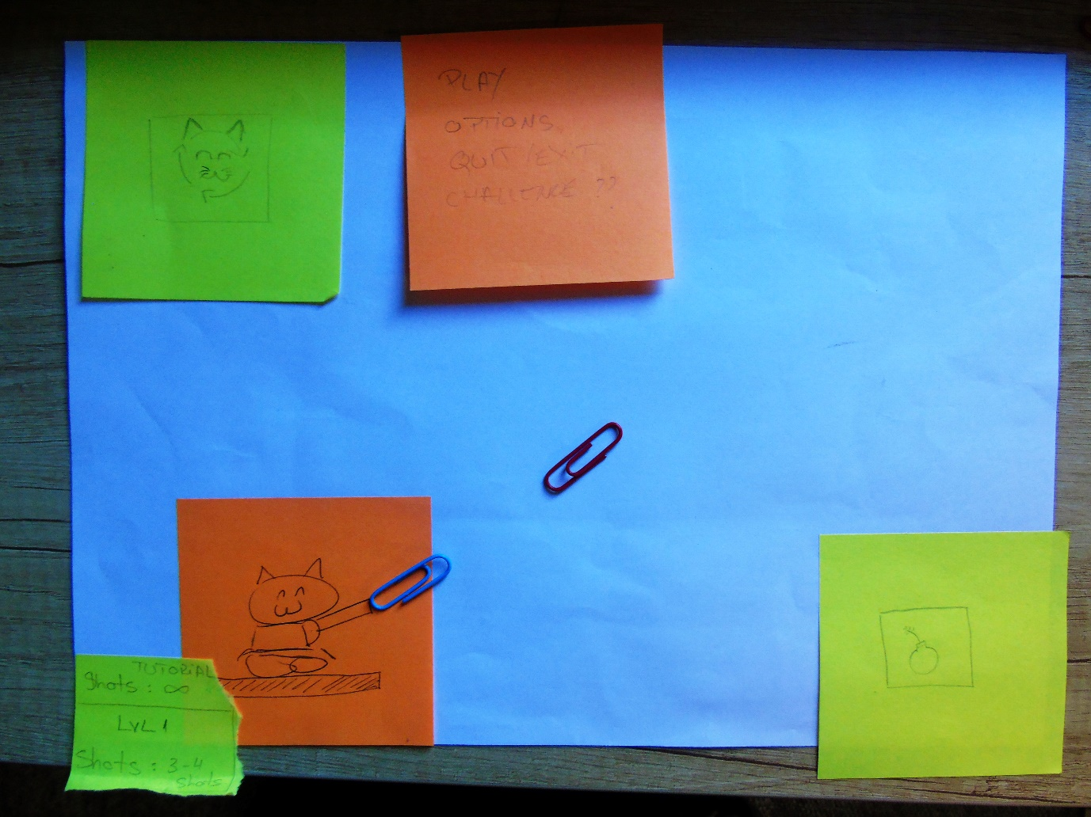each available cat tank should be represented as the toes of a cat’s paw.

6

5

1

2

3

4

The player is expected to angle the gun by moving their finger on the screen. When happy with the angle, they shall hit the fire button, and the projectile shall be launched towards the right. This takes us to the next screen.

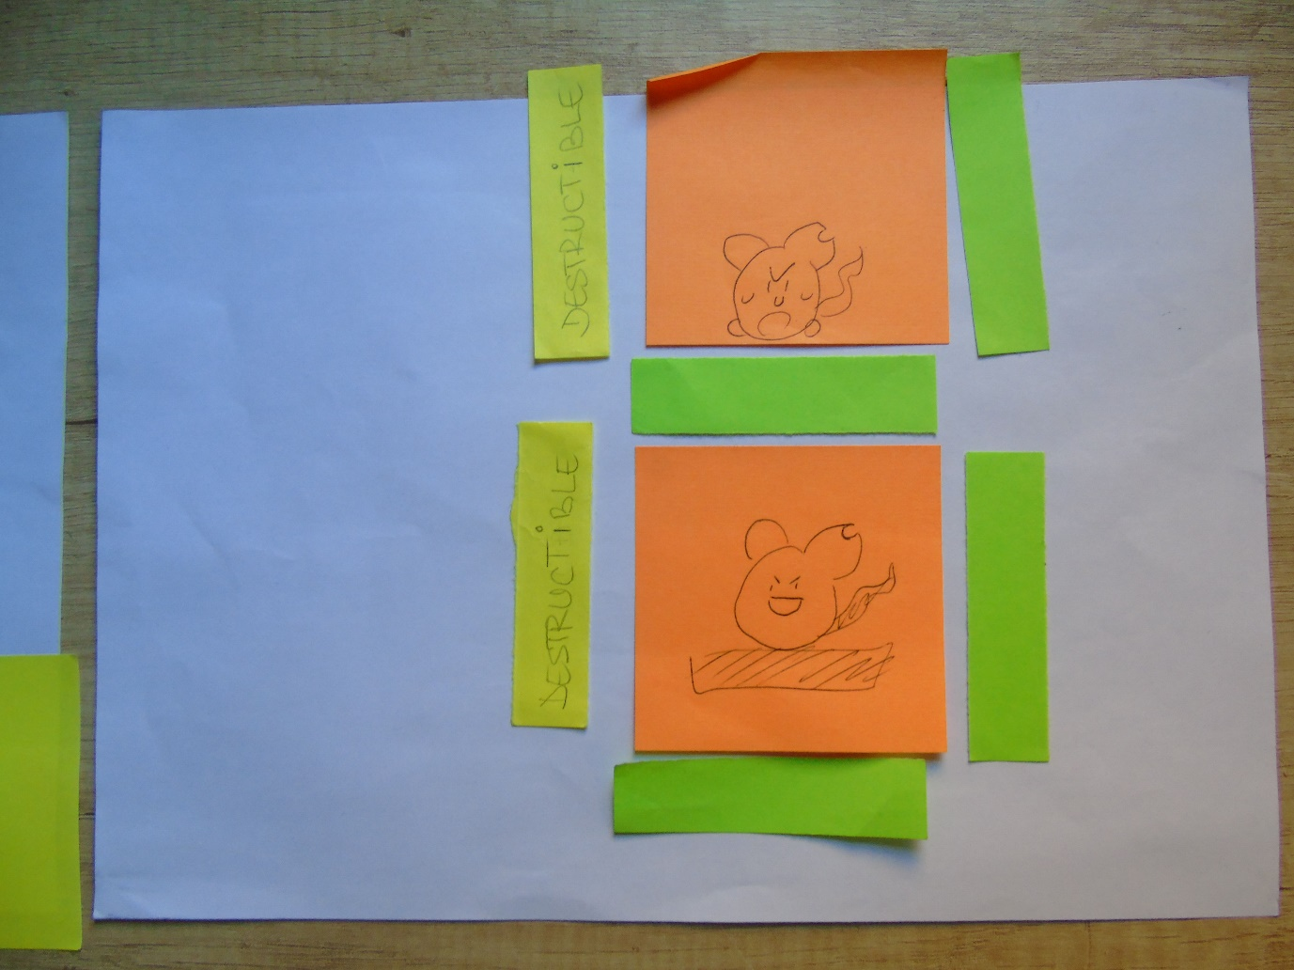Here, we can see the design of the example level. The Enemies are on the orange post-it notes, and the green boxes represent indestructible blocks of stone. The yellow boxes with destructible written on them are, as labelled, destructible, and should be visually different from the other planks. We plan to have destroyable wooden planks and indestructible stone blocks. When the projectile hits the wooden planks or mice, both the projectile and the object it hit will disappear.

With this layout, the player should hopefully shoot the wooden planks. On their destruction, the player will then be able to shoot the mice. The player can only kill one at a time. This way, the player learns that the level has destroyable elements, and requires all the mice to be killed for them to advance the stage.

With this level, we teach the player that wooden planks are destructible, stone planks are not, and all mice must die to advance. We shall give the player infinite shots to complete this level, and we will indicate this in the Head Up Display in the bottom left hand corner alongside the level name.

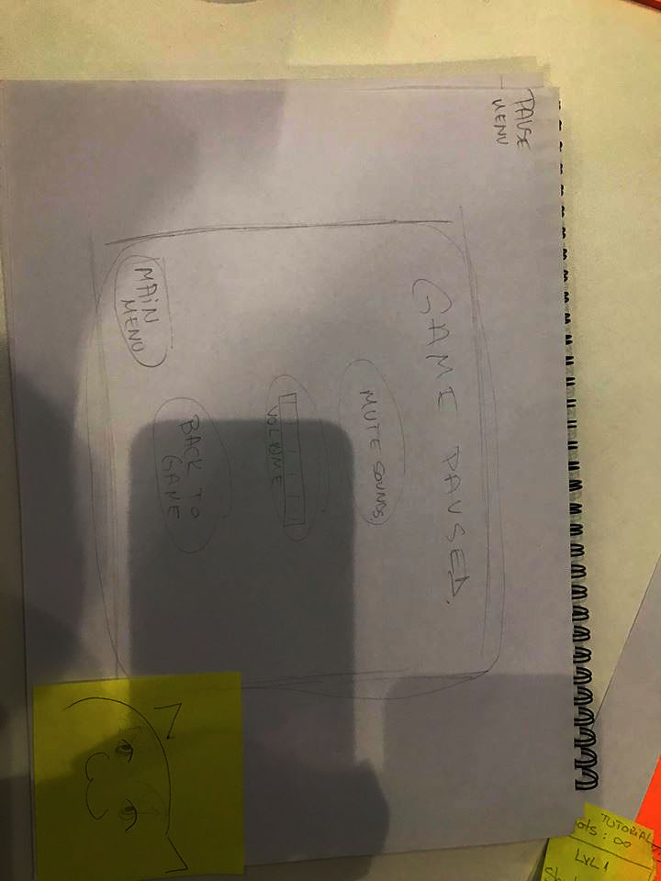The game paused screen has 4 buttons. Mute sounds, volume control, back to game, and main menu. The screen will be kept very basic, so that it is easy for the player to read. After some later lectures, we realise that some symbols, such as a speaker next to the sound, could help our game to be more easily understood. There was an idea for a cat to be at the bottom of the screen. His eyes would follow your finger/cursor as it moved on screen. However, this is low on the priority list, as it is a wish and not a necessity.

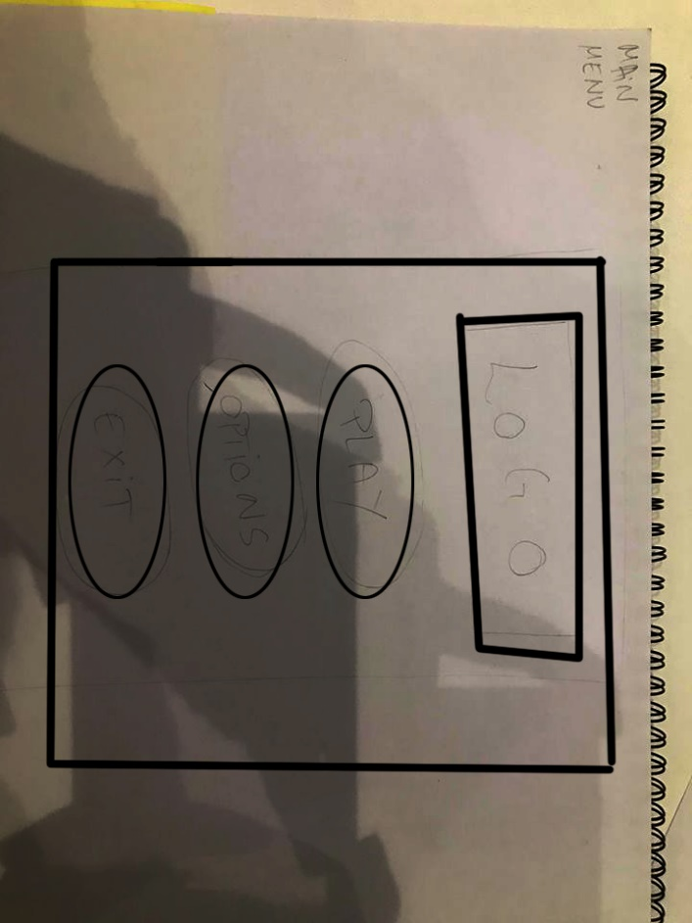The main menu screen is also simple, with similar intent of easily readable. It will have our game logo in the centre at the top. Then buttons below it in descending importance; play; options; exit.

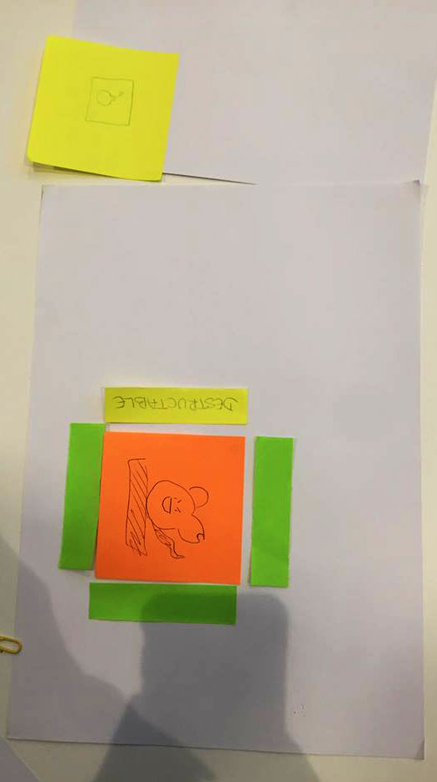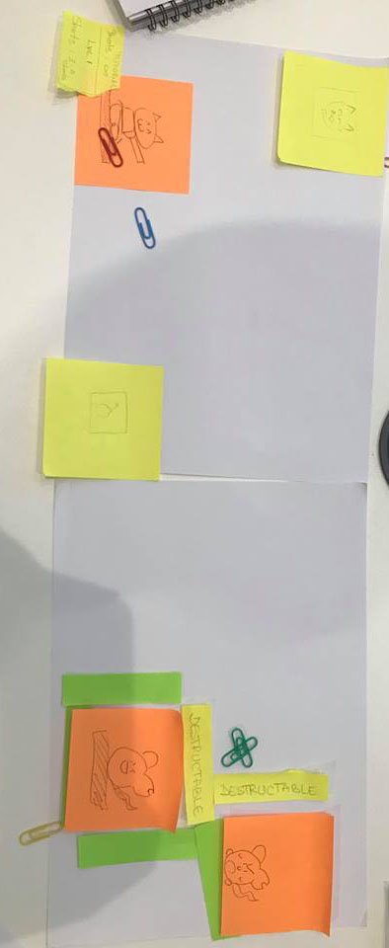Below are some of our earlier level designs. They have the goal of teaching the player basic parts of the game. The first is similar to the above example level, with a destructible plank in front of the enemy mouse. The second has a falling spike ball (represented by two green paper clips, [!]). The spike ball will kill a mouse if the ball falls on the mouse. The destructible planks are likely to be shot, and so, the player will then learn that the falling spike ball hurts the mouse.

!